FACILITATORS GUIDE/AGENDA
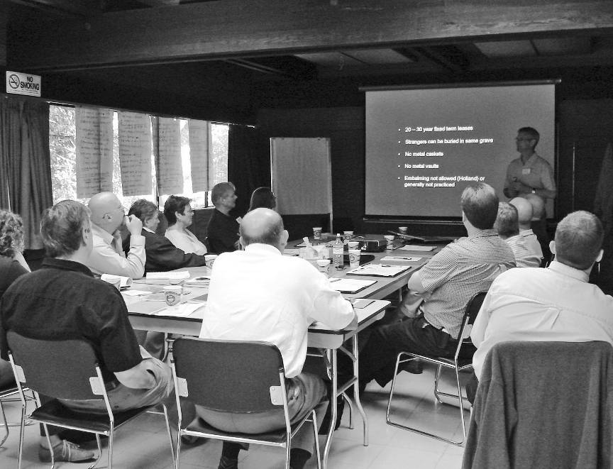

Creating Healthy Built Environments:

Introduction to Land Use Planning for Health Professionals

COMPANION TO WORKSHOP AGENDA SAMPLE #1

- Workshop Agenda –
SAMPLE #1
Creating Healthy Built Environments:
Introduction to Land Use Planning for Health Professionals

8:30-9:00 | Registration and Refreshments
9:00-9:15 | Introductions
9:15-9:30 | Setting the Stage: Introductions, History and Workshop Purpose  - Who: Manager, Director or Executive Director  - Provincial context (overview of other healthy built environment activity in the province - e.g., other workshops)  - Expectations for the workshop (to learn, share ideas, discuss next steps)  - Introduce facilitators
9:30-10:15 | Presentation 1: Foundations for a Healthier Built Environment  - Who: Medical Health Officer  - Key points from paper, Foundations for a Healthier Built Environment, including relevancy and role of health professionals  - Business case for healthy built environment (HBE) work
10:15-10:30 | BREAK
10:30-11:30 | Presentation 2: Overview of Training Module  - Who: Workshop Facilitator  - Context, process, policies, and opportunities for engagement  - Planning tools and strategies available (definitions and benefits)  - Identify emerging HBE policies and programs (e.g., zoning for healthy foods, etc.)  - Identify typical opportunities to intervene/become involved  - Introduce informal ways of becoming involved with the health professional (HP) as advocate

11:30-12:00 | Large Group Discussion: Who’s Who?  - Who: Workshop Facilitator or Local Planner(s)  - Identify different levels of planners and their roles  - Highlight differences between urban and rural planning offices  - Identify allied groups and organizations beyond “The Hall” HPs can work with – ranging from Planning Institute of BC to environmental and social justice community groups, from Urban Development Institute and Union of BC Municipalities to rancher associations  - Identify who the organizations are, who they represent, and what they typically do vis-à-vis land use decision-making  - Include ideas for how to build relationships with these organizations beyond formal land use planning processes
12:00-1:00 | LUNCH
1:00-1:30 | Introduction to Land Use Planning Examples  - Who: Workshop Facilitator  - Who: Local Planner(s)  - Example 1: Local Electoral Area Official Community Plan  - Example 2: Local Regional Growth Strategy
1:30-2:45 | Activity - Working Through Land Use Planning Examples  - Depending on numbers this activity may involve the group splitting into two smaller groups  - Purpose of activity:  - To explore where and how health professionals can be most effective and strategic (who to talk to, when, at what stage?)  - Questions:  - Are there any potential HBE implications – impacts associated with the project? What are they?  - Could they be addressed/mitigated to some degree? How?  - Who could intervene/provide feedback? How? At what stage?  - Could others be strategically involved or engaged? Who? How?  - What are the obstacles or barriers (policy, legal, time, perceptual, organizational, administrative, etc.)?
2:45-3:00 | BREAK

3:00-3:45 | Activity - Working Through Land Use Planning Examples (continued)
3:45-4:30 | Next Steps and Wrap-up  - Review  - Workshop evaluation  - Workshop closing  - What have we learned?  - Where do we go from here?  - Who could participants collaborate with? What informal and formal participation mechanisms could they use? What planning processes could be an opportunity to be involved?

