Templated CARD surveys for vaccine clients

This document contains four surveys as described below. These documents can be found at CardSystem.ca.

- Tell us how you feel!
For individuals aged 8 years and older

Client vaccine symptom and feedback survey. Suitable for individuals aged 8 years and older undergoing vaccination.

Provide to clients after vaccination. Use feedback to inform interactions and future practice.
- Tell us how you feel!
For individuals aged 5-7 years

Client vaccine symptom and feedback survey. Suitable for individuals aged 5-7 years undergoing vaccination.

Provide to children and parents/guardians after vaccination. Children can be assisted by parents/guardians or staff when completing it. Use feedback to inform interactions and future practice.
- Tell us how you feel!
For parents and caregivers

Parent/caregiver vaccine feedback survey: For parents/guardians of children undergoing vaccination or caregivers of other individuals undergoing vaccination.

Provide after vaccination. Use feedback to inform interactions and future practice.

Tell us about what happened so we can help to make vaccinations a better experience for you and for others getting vaccinated in our clinic.
- Tell us how much the needle hurt.
Pick a number from 0 to 10, where 0 is no pain at all and 10 is the most pain possible.
0 1 2 3 4 5 6 7 8 9 10
- Tell us how scared or worried you were about the needle.
Pick a number from 0 to 10, where 0 is not scared or worried at all and 10 is the most scared or worried possible.
0 1 2 3 4 5 6 7 8 9 10
- Tell us how dizzy you were before, during and after the needle.
Pick a number from 0 to 10, where 0 is not dizzy at all and 10 is most dizzy possible.
0 1 2 3 4 5 6 7 8 9 10 I fainted
- We use the CARD system in our clinic. We ask people to choose what they want to do to make getting vaccinations more comfortable. Tell us how much using CARD helped you with your vaccination today.
Not at all A little bit A medium amount A lot
- Compared to the last time you got a vaccine, tell us if today’s vaccine was better, worse, or the same.
Better The same Worse I don’t know I don’t remember
- Do you want to use CARD again if you ever get another vaccination?
Yes No I don’t know
- Tell us about anything that helped make the vaccine injection LESS painful, scary or stressful.

- Tell us about anything that made the vaccine injection MORE painful, scary or stressful.

- What vaccine did you get today?
COVID-19 Influenza (Flu) Human papillomavirus (HPV) Hepatitis B Other:
- How old are you? _____ years
- Which of the following best describes you? Female Male Other:

Tell us about what happened so we can help to make vaccinations a better experience for you and for other kids getting vaccinated in our clinic.
- Tell us how much the needle hurt.
"These faces show how much something can hurt. This face [point to left-most face] shows no hurt or pain. The faces show more and more hurt or pain [point to each from left to right] up to this one [point to right-most face] – it shows very much hurt or pain. Point to the face that shows how much you hurt during the needle."
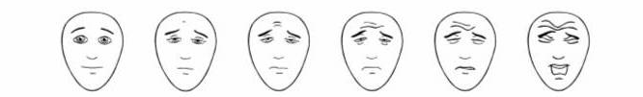

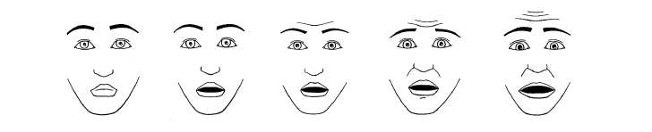
- Tell us how scared you were about the needle.
“These faces are showing different amounts of being scared. This face [point to the left-most face] is not scared at all, this face is a little bit more scared [point to second face from left], a bit more scared [sweep finger along scale], right up to the most scared possible [point to the last face on the right]. Have a look at these faces and choose the one that shows how scared you were during the needle.”

- Tell us whether you were dizzy (shaky, wobbly) before, during or after the needle.
Not at all A little bit A medium amount A lot I fainted
- We use the CARD system in our clinic. We ask kids to choose what they want to do to make getting a needle easier for them. Tell us how much this helped you with your needle today.
Not at all A little bit A medium amount A lot
- Compared to the last time you got a needle, tell us if today’s needle was better, worse, or the same.
Better The same Worse I don’t know I don’t remember
- Tell us about anything that helped make the needle LESS painful, scary or stressful.

- Tell us about anything that made the needle MORE painful, scary or stressful.

- What vaccine did you get today?
COVID-19 Influenza (Flu) Human papillomavirus (HPV) Hepatitis B Other:
- How old are you? _____ years
- Which of the following best describes you? Girl Boy Other:

Tell us about what happened so we can help to make vaccinations a better experience for you, your child/loved one, and others getting vaccinated in our clinic.
- Relationship to vaccine client:
- Tell us how much pain you think your child/your loved one had during the needle.
Pick a number from 0 to 10, where 0 is no pain and 10 is most pain possible.
0 1 2 3 4 5 6 7 8 9 10
- Tell us how scared or worried you think your child/your loved one was about the needle.
Pick a number from 0 to 10, where 0 is not scared or worried at all and 10 is the most scared or worried possible.
0 1 2 3 4 5 6 7 8 9 10
- Tell us how scared or worried you were about your child’s/loved one’s needle. Pick a number from 0 to 10, where 0 is not scared or worried at all and 10 is the most scared or worried possible.
0 1 2 3 4 5 6 7 8 9 10
- We use the CARD system in our clinic. We ask people to choose what they want to do to make vaccinations more comfortable. Tell us how much this helped your child/loved one with their vaccination today.
Not at all A little bit A medium amount A lot
- How did your experience with your child/loved one’s vaccination today compare with the last time they got a vaccine?
Better The same Worse I don’t know I don’t remember
- Do you want to use CARD again if your child/loved one ever gets another vaccination?
Yes I don’t know No
- Tell us about anything that helped make the vaccine injection LESS painful, scary or stressful.

- Tell us about anything that made the vaccine injection MORE painful, scary or stressful.

- What vaccine did your child/loved one get today?
COVID-19 Influenza (Flu) Human papillomavirus (HPV) Hepatitis B Other:
- How old are you? _____ years
- Which of the following best describes you? Female Male Other:

